Assignment2.2

Yellow key icon: primary key

White diamond icon: a column

Blue diamond icon: a column has NN set.

Red Key icon: Foreign Key association.

Q1:

This question requires you to add two tables: “classes” and “student_classes”.

The “classes” table is mentioned in the links, providing a hint to include it.

On the other hand, “student_classes” is not explicitly listed among the tables but is necessary due to the many-to-many relationship between the “students” and “classes” tables. Therefore, a table needs to be added in between to establish a relationship of 1-to-many. This is similar to the relationship between the “actor” and “film” tables in “sakila” database, which is also many-to-many. However, by introducing the “film_actor” table in between, the relationship is corrected to 1-to-many.

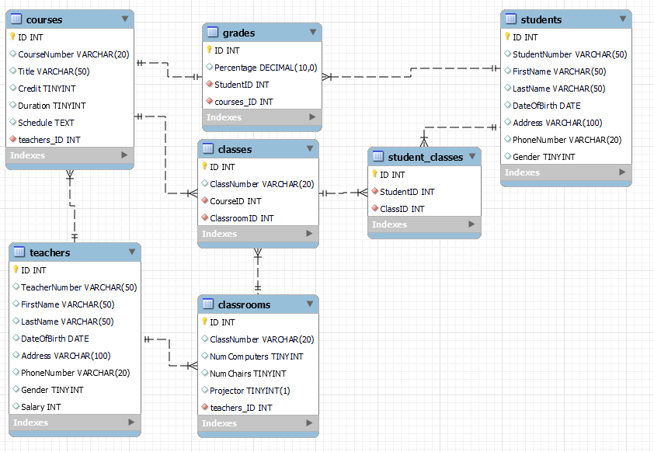

Q2:

